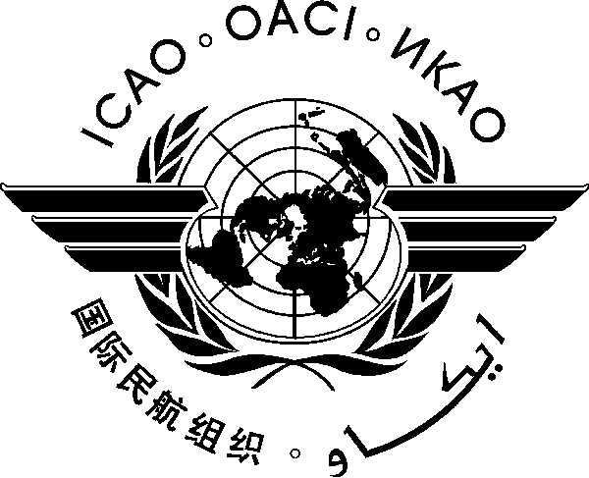

INVITATION TO ATTEND:

- Africa-Indian Ocean (AFI) Aviation Security and Facilitation Plan (SECFAL) Meeting,
- 15th Comprehensive Regional Implementation Plan for Aviation Safety in Africa (AFI Plan) Steering Committee Meeting,
- 2nd AFI Aviation Safety Symposium; and
- AFI Human Resources Development Fund (HRDF) Meeting

(Maputo, Mozambique, 18 to 21 May 2015)

REGISTRATION FORM

- Please fill and forward the form in the same (MS Word) format. Do not fax, scan or change format to PDF.
- Insert information in the grey empty boxes
- Where appropriate, click to make the appropriate selection
Register for the following events: Please select at least one event to complete the registration
SECFAL Plan Meeting - 18 May | 15th AFI SC Meeting - 19 May
Aviation Safety Symposium - 20 May | AFI HRDF Meeting - 21 May

- Surname

- Given Name (s)

- Job Title

- Category
- Role in this Event
- State/Organization

- Mailing Address

- Telephone

- Fax

- E-mail address

- Hotel

- I will be accompanied

Note: Participants are expected to make their own hotel/visa arrangements. Hotel information is provided in the information bulletin.

Please complete and return this form to: The Regional Director
ICAO ESAF Regional Office, Nairobi, Kenya
Email: icaoesaf@icao.int
Fax: +254 20 762 109

