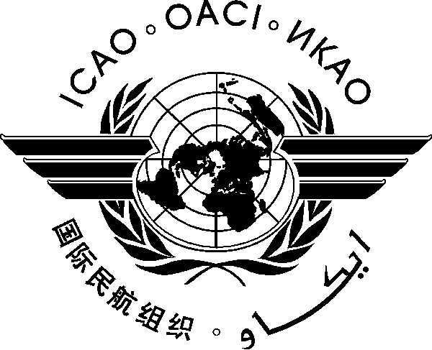
INTERNATIONAL CIVIL AVIATION ORGANIZATION
EASTERN AND SOUTHERN AFRICAN OFFICE

Workshop on the Aviation System Block Upgrade (ASBU) methodology
for planning and implementation of air navigation systems

(Nairobi, Kenya, 7-11 October 2013)

REGISTRATION FORM

- Please fill and forward the form in the same (MS Word) format. Do not fax, scan or change format to PDF.
- Insert information in the grey empty boxes
- Where appropriate, click to make the appropriate selection

- Surname

- Given Name (s)

- Job Title

- State/Organization

- Mailing Address

- Telephone

- Fax

- E-mail address

- Hotel

Note: Participants are expected to make their own hotel/visa arrangements. Hotel information will be provided in the information bulletin.

Please complete and return this form to:

The Regional Director  ICAO ESAF Regional Office  Nairobi, Kenya  Fax: +254 20 762 1092  Email: ICAOESAF@icao.int  Copy to : RMuhanji@icao.int | The Regional Director  ICAO WACAF Regional Office  Dakar, Senegal  Fax: +221 33 820 32 59  Email: ICAOWACAF@icao.int  Copy to: FMaiga@icao.int

- - - - - - - - - -

