International Civil Aviation Organization
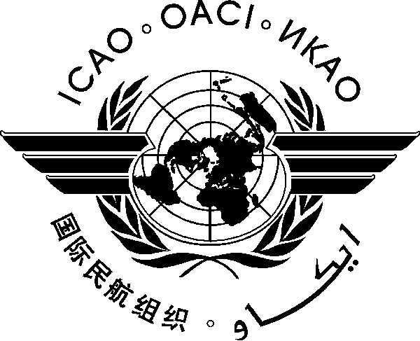
ICAO Seminar/Workshops (Addis Ababa, Ethiopia)
- Aviation System Block Upgrades (ASBU), 17-19 November 2014; and
- African Flight Procedure Programme (AFPP), 20-21 November 2014

REGISTRATION FORM

- Please fill and forward the form in the same (MS Word) format. Do not fax, scan or change format to PDF.
- Insert information in the grey empty boxes
- Where appropriate, click to make the appropriate selection

- Surname

- Given Name (s)

- Job Title

- State/Organization

- Mailing Address

- Telephone

- Fax

- E-mail address

- Hotel

Note: Participants are expected to make their own hotel/visa arrangements. Hotel information will be provided in the information bulletin.

Please complete and return this form to: The Regional Director
ICAO ESAF Regional Office, Nairobi, Kenya
Email: icaoesaf@icao.int
Fax: +254 20 762 1092

Copy to: SMachobane@icao.int

