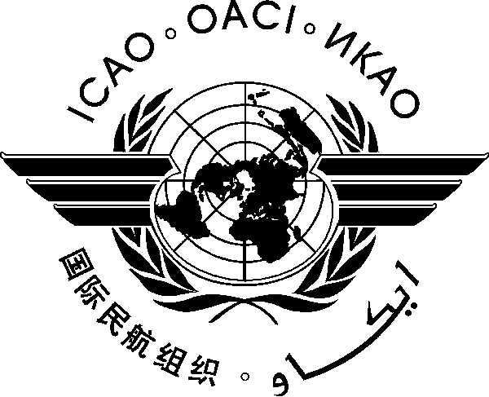
INTERNATIONAL CIVIL AVIATION ORGANIZATION

Seminar ON Air Traffic Services (ATS) Incident Investigation and Report Writing Training AT ESAF Regional Office
(NAIROBI, Kenya 18 to 22 July 2016)

REGISTRATION FORM

- Please fill and forward the form in the same (MS Word) format. Do not fax, scan or change format to PDF.
- Insert information in the grey empty boxes
- Where appropriate, click to make the appropriate selection

- Surname

- Given Name (s)

- Title or Official Position
- UN Agency/Programme
- Mailing Address

- Telephone Number

- Mobile Number
- E-mail address

- Hotel

Note 1: Participants are expected to make their own hotel/visa arrangements. Information on your, hotel accommodation will be used for purposes of Transport Arrangements only.

Note 2: For referred States, the visa arrangements need to be done in coordination with ICAO ESAF Regional Office.

Please complete and return this form to: The Regional Director
ICAO ESAF Regional Office, Nairobi, Kenya
Email: ICAOESAF@icao.int

Copy to: SMachobane@icao.int

