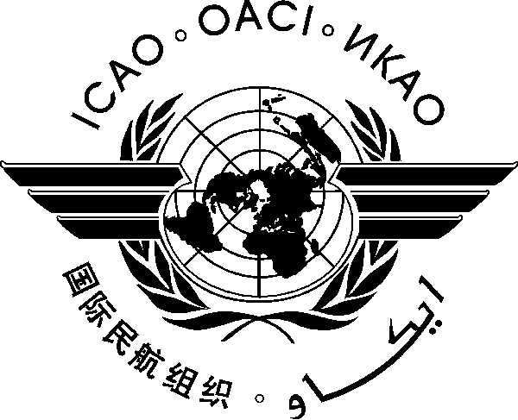

Workshop on the Provision and Improvement of Search and Rescue Services in the AFI Region
(Mahe, Seychelles, 19 to 22 July 2016)

REGISTRATION FORM

- Please fill and forward the form in the same (MS Word) format.
- Insert your information in the grey empty boxes

- Surname

- Given Name (s)

- Job Title

- State/Organization

- Mailing Address

- Telephone

- Fax

- E-mail address

- Name of hotel in Seychelles

- Flight number and date of arrival

Please complete and return this form to: The Regional Director
ICAO ESAF Regional Office
Nairobi, Kenya
Email: icaoesaf@icao.int
Fax: +254 20 762 1092

Copy to: dlabrosse@icao.int

