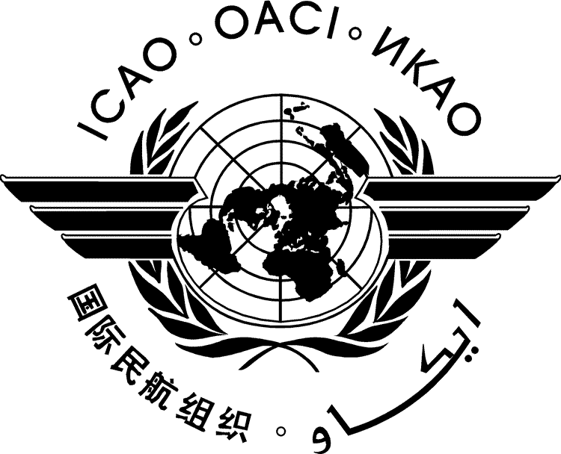 | International Civil Aviation Organization  INFORMATION PAPER
  HLSC/15-IP/xxxx
  ../../14
SECOND HIGH-LEVEL SAFETY CONFERENCE 2015 (HLSC 2015)
PLANNING FOR GLOBAL AVIATION SAFETY IMPROVEMENT

Montréal, 2 to 5 February 2015

Theme | 1: | Reviewing the current situation
Topic | 1.1: | Achievements and remaining work
Topic | 1.2 | Emerging safety issues
Theme | 2: | Future approach to manage aviation safety
Topic | 2.1: | State safety programme
Topic | 2.2: | Safety information protection
Topic | 2.3: | Safety information sharing
Topic | 2.4: | Evolution of the Global Aviation Safety Plan
Theme | 3: | Facilitating increased regional cooperation
Topic | 3.1: | Effective and efficient regional collaboration

TITLE

(Presented by the ICAO Secretariat)

SUMMARY
This information paper presents…..

  - ...…

  - …

— — — — — — — —

HLSC/15-IP/xxxx
Appendix

APPENDIX

TITLE

- HEADING
  - …

— END —

