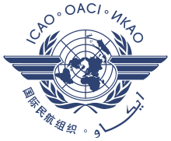 | 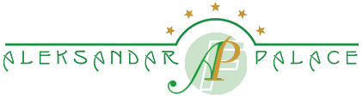 | 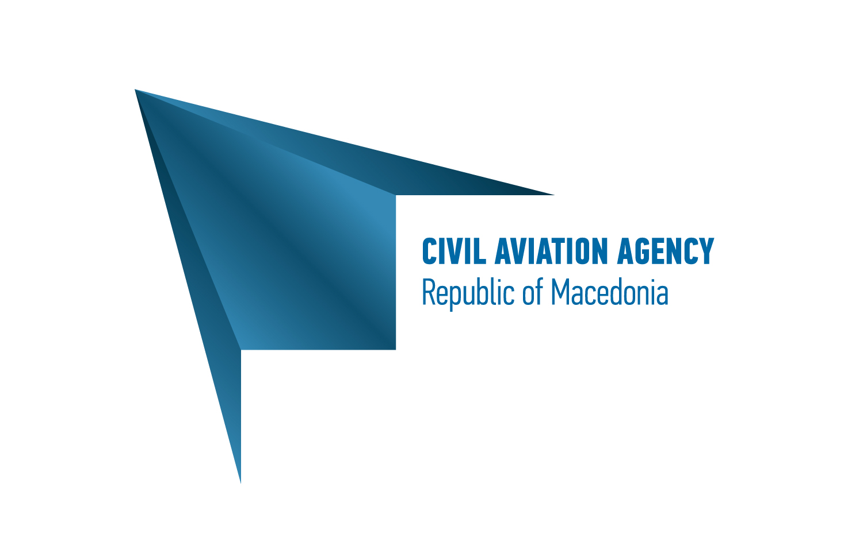

8 Septemvri No. 15, 1000 Skopje, the Former Yugoslav Republic of Macedonia

RESERVATION FORM

ICAO Regional Seminar on CORSIA
26th till 28nd of March 2018, Skopje

Name:______________________________

Surname: ______________________________

Please book on my behalf 1 room for the period of _________ → _________ number of nights ____.

I would like to book:

Single Room At the special rate of 68 Euro/room/night

Room rates include Buffet Breakfast (for 2 persons in the Double Room) and local taxes (VAT 5% and all other applicable taxes).

Method of guarantee and advance Payment

Credit Card, type:____________ No.________________________ Exp. Date__________

Card holder signature: __________________________

Or

Deposit in Advance: please contact the hotel for advance payment by bank transfer. Payment by bank transfer must be done before

The above mentioned rates are valid only for this event, from 25th till 28nd of March, 2018.

Any guest room reservations confirmed and guaranteed through the Reservation Form, 7 days before arrival not claimed on the day of arrival (no show), will be canceled and the credit card will be charged with 100% penalty for the entire length of stay.

Shuttle Service is available to and from the Airport! Price: 26 Euro/ one way transfer (VAT included)!
For reservations please send a fax to:+389 2 3092 152 or email info@aleksandarpalace.com.mk!

Thank you for booking with us!
Tel.: +389 2 3092 392, Fax: +389 2 3092 152

