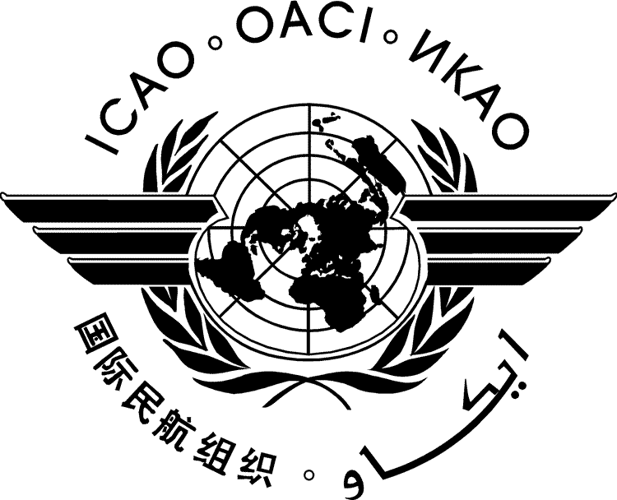 | International Civil Aviation Organization  WORKING PAPER
  HLCAS-WP/xxxx
  ../../12
HIGH-LEVEL CONFERENCE ON AVIATION SECURITY (HLCAS)

Montréal, 12 to 14 September 2012

Agenda Item | 1: | Global Risk Context Statement
Agenda Item | 2: | Enhancing air cargo security
Agenda Item | 3: | Combating the insider threat
Agenda Item | 4: | Evolution of the Universal Security Audit Programme
Agenda Item | 5: | Capacity building and technical assistance
Agenda Item | 6: | Ensuring the sustainability of aviation security measures
Agenda Item | 7: | The role of the Machine Readable Travel Document (MRTD) Programme, Advance Passenger Information (API) and Passenger Name Record (PNR)
Agenda Item | 8: | Driving technology developments and innovation
Agenda Item | 9: | Any other business

[INSERT TITLE]

(Presented by )

SUMMARY
This paper presents the...

Action: The High-level Conference on Aviation Security is invited to endorse the action(s) proposed in paragraph 2.
- INTRODUCTION
  - ...
- CONCLUSION
  - The High-level Conference on Aviation Security is invited to...

— END —

