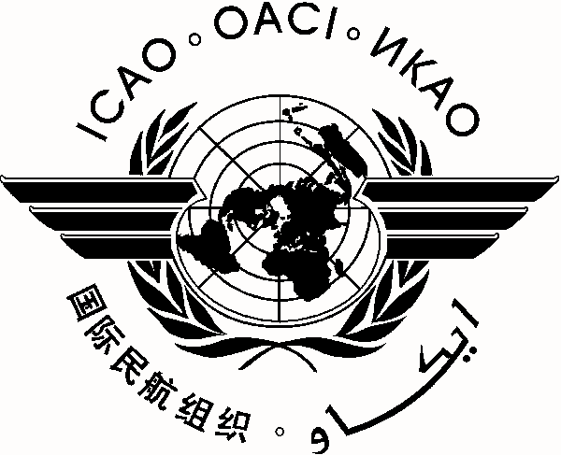 |  | E/CAR/DCA/25
 | International Civil Aviation Organization
 | North American, Central American and Caribbean Office (NACC)
 | Twenty-fifth Meeting of Directors of Civil Aviation of the Eastern Caribbean (E/CAR/DCA/25)
 | (St. John’s, Antigua and Barbuda, 3–5 December 2013)

REGISTRATION FORM

1. | Name
2. | Position
3. | Organization
4. | Country
5. | Telephone
6. | E-mail

Please send this form to:
E-mail: icaonacc@icao.int

