IAT/5 — PA-RAST/15
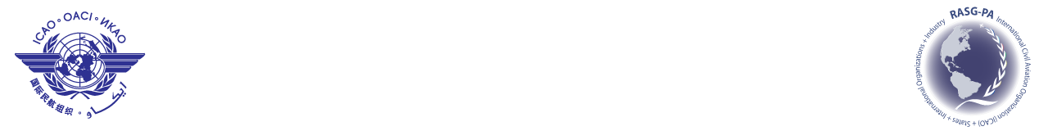
International Civil Aviation Organization
Fifth Information Analysis Team Meeting (IAT/5)
Fifteenth Pan America — Regional Aviation Safety Team Meeting
(PA-RAST/15)
Ft. Lauderdale, Florida, United States, 22 to 24 January 2014

Attending:
IAT/5 Meeting  (22 January 2014) |  | PA-RAST/15 Meeting  (23 – 24 January 2014)

REGISTRATION FORM

1. | Name
2. | Position
3. | Organization
4. | Country
5. | Telephone
6. | E-mail

Please send this form to:
E-mail: icaonacc@icao.int

