IAT/6 — PA-RAST/16
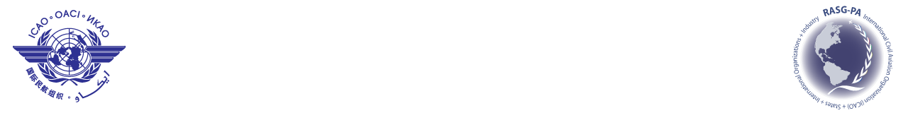
International Civil Aviation Organization
Sixth Information Analysis Team Meeting (IAT/6)
Sixteenth Pan America — Regional Aviation Safety Team Meeting
(PA-RAST/16)
Panama City, Panama, 27 to 29 March 2014

Attending:
IAT/6 Meeting  (27 March 2014) |  | PA-RAST/15 Meeting  (28 – 29 March 2014)

REGISTRATION FORM

1. | Name
2. | Position
3. | Organization
4. | Country
5. | Telephone
6. | E-mail

Please send this form to:
E-mail: icaonacc@icao.int

