AIDC - WP/XX
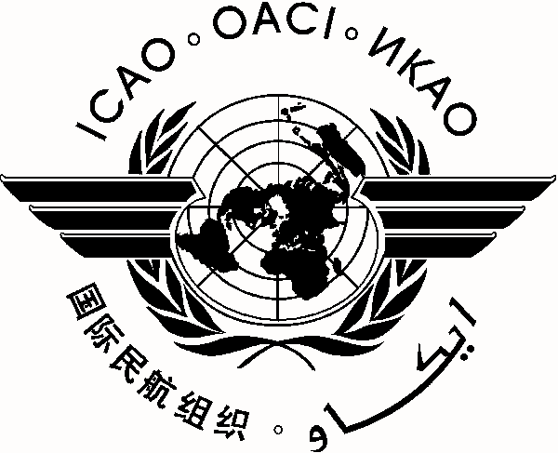
International Civil Aviation Organization **/**/18
NAM/CAR/SAM Regions Air Traffic Services Inter-facility Data Communication (AIDC) Implementation Meeting

(Lima, Peru, 16 – 20 April 2018)

Agenda Item *:

TITLE OF WORKING PAPER

(Presented by ***)

SUMMARY

References:

1. Introduction

1.1

2. Discussion

3. Suggested Action

- - - - - - - -

or

- END -

