- Analysis Not Started – The requirement to implement this ASBU Element has not yet been assessed
- Analysis In Progress – A Need Analysis as to whether or not this ASBU Element is required, is in progress
- N/A – The ASBU Element is not required
- Need - The Need Analysis concluded that the ASBU Element is required, but planning for the implementation has not yet begun
- Planning – Implementation of this ASBU Element is planned, but not yet started
- Developing – Implementation of this ASBU Element is in the development phase, but not yet operational
- Partially Implemented – Implementation of this ASBU Element is partially completed and/or operational but all planned implementations are not yet complete
- Implemented - Implementation of this ASBU Element has been completed and/or is fully operational everywhere the need was identified
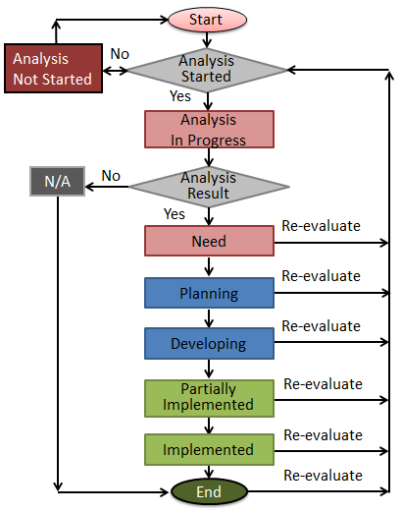
Figure 1.4.1: Analysis and Work Flow

