GREPECAS/17 – WP/xx
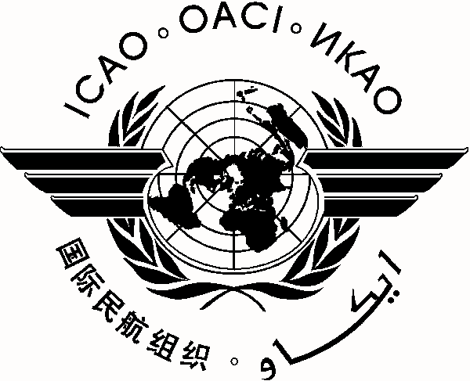
International Civil Aviation Organization 0X/0X/14

CAR/SAM Regional Planning and Implementation Group (GREPECAS)
Seventeenth Meeting of the CAR/SAM Regional Planning and Implementation Group (GREPECAS/17)
(Cochabamba, Bolivia (Plurinational State of), 21 to 25 July 2014)

Agenda Item *:

TITLE OF WORKING PAPER

(Presented by ***)

SUMMARY

References:

1. Introduction

1.1

- END –

Or

- - - - - -

