PPRC/2 - IP/**
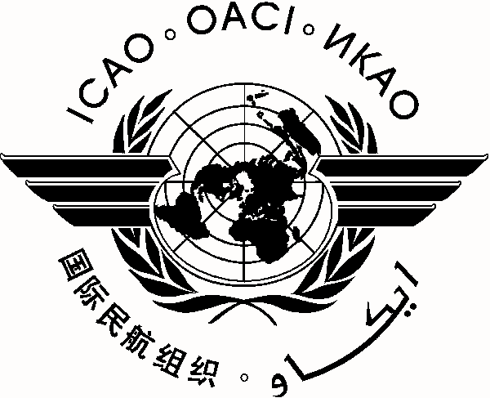
International Civil Aviation Organization **/**/13

CAR/SAM Planning and Implementation Regional Group (GREPECAS)
Second Meeting of the Programmes and Projects Review Committee (PPRC/2)
Lima, Peru, 16 - 18 July 2013

Agenda Item *:

TITLE OF INFORMATION PAPER

(Presented by ***)

SUMMARY

References:

Strategic Objective(s) | This working paper is related to Strategic Objective(s) A – Safety  C – Environmental Protection and Sustainable Development of Air Transport.

1. Introduction

1.1

- - - - - - - -

or

- END -

