PPRC/1 – WP/xx
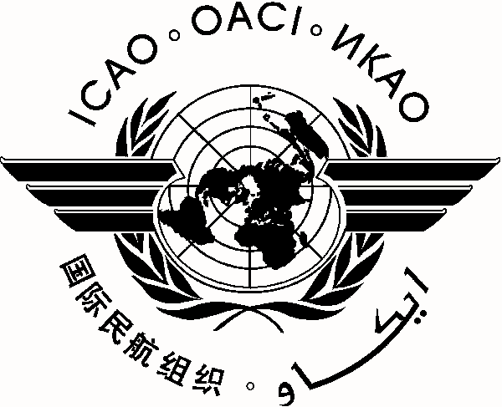
International Civil Aviation Organization 0X/0X/13

CAR/SAM Planning and Implementation Regional Group (GREPECAS)
Second Meeting of the Programmes and Projects Review Committee (PPRC/2)
Lima, Peru, 16 - 18 July 2013

Agenda Item *:

TITLE OF WORKING PAPER

(Presented by ***)

SUMMARY

References:

Strategic Objective(s) | This working paper is related to Strategic Objective(s) A – Safety  C – Environmental Protection and Sustainable Development of Air Transport.

1. Introduction

1.1

- END –

Or

- - - - - -

