
Fifteenth RVSM/TF meeting
WP/4
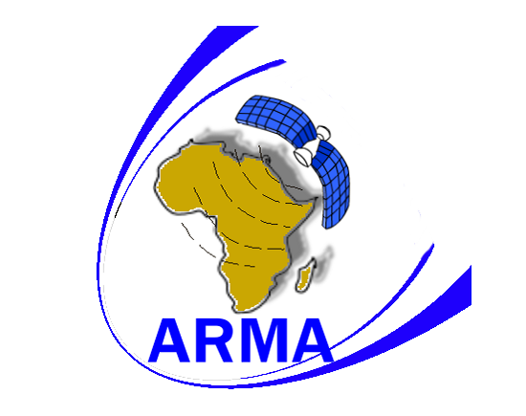

INTERNATIONAL CIVIL AVIATION ORGANIZATION

FIFTEENTH Meeting of the RVSM Task Force
(DAKAR, 11 MAY, 2009)

Agenda Item 3: AFI RVSM Post Operational Safety Case

Presented By: ARMA

SUMMARY: This Working Paper discusses and provides insight into the AFI RVSM Post Operational Safety Case (POSC) process.

INTRODUCTION

The AFI Region after 14 AFI RVSM Task Force Meetings has safely and successfully implemented RVSM in the Region on 25 September 2008. As required by the AFI RVSM Safety Policy (Section 6.5), a Post-Implementation Safety Case shall be produced to ensure that on-going RVSM operations will meet all safety expectations. The following is extracted from the policy for ease of reference:

“The required contents of the Post-Implementation Safety Case will be developed as a result of the pre-implementation safety activities. However, the main objective will be to confirm assumptions and estimations being made in order to determine if in an operational RVSM environment the safety objectives can be met. It is expected that the document demonstrates inter alia that safety is continuously ensured, the aircraft approval process is effective, the target levels of safety are being met, operational errors do not increase and ATC procedures introduced for RVSM remain effective.”

DISCUSSION

ALTRAN Technologies who were contracted to assist with both the development of the NSP, FHA and PISC have been contracted to ensure continuity, to assist ARMA in the development of a robust Post-Implementation Safety Case (POSC). This process will assist ARMA with the follow up activities that are required to meet the safety objectives. The process will also inter-act and relate to the ICAO Tactical Action Group (TAG) as recommended by AFI RAN/8 Recommendation 6/7. The establishment of an AFI RVSM scrutiny group as recommended at AFI RAN/8 recommendation 6/8 (e) will satisfy the evaluation and validation of Large Height Deviations which will be worked into the POSC as well as the Collision Risk Assessment which will be undertaken by NLR in order to establish the RVSM collision risk in AFI.

The POSC will be constructed to demonstrate by means of argument and supporting evidence that: AFI RVSM operations are and will continue to be safe with reference to specified time periods after implementation. The ultimate aim will be to demonstrate that RVSM in the AFI Region satisfies and will continue to satisfy the criteria defined in the AFI RVSM Safety Policy and in the AFI RVSM Pre-Implementation Safety Case.

For easy reference, the acceptable level of AFI RVSM safety, is defined by the safety objectives set out in the AFI RVSM Safety Policy that will form the basis for demonstrating the ongoing safety of AFI RVSM.

Essentially the POSC shall focus on service monitoring and general operational experience during actual operations.
States will be periodically requested to provide evidence that will only address national RVSM safety performance as integrated into their safety assurance processes.

In a similar way, with reference to the model used by AFI for RVSM implementation, a twofold strategy for safety argument and supporting evidence is envisaged and should be followed to demonstrate that the POSC aim is achieved. This will be achieved by:

- Measuring the degree of success in achieving the RVSM safety objectives as evidence for the continued safe use of RVSM in AFI

- Confirming the validity of the PISC by reporting all issues in it that were ongoing at the time that the final version was issued.

During the POSC process extensive use and reference will be made to the root documents compiled prior to implementation. We should recall that these documents are the:

- National Safety Plans compiled by each AFI State
- AFI RVSM Functional Hazard Assessment
- Collision Risk Assessments compiled prior to implementation as well as the pending Assessment

It is envisaged that the initial composition of the Pre Implementation PMT be retained to guide the process and that email correspondence should be the main source of completing the task. Any POSC Management meetings should coincide with already scheduled events for cost savings. The POSC Management Team members are:

- Altran Tech & NLR when required
- ARMA (Facilitator)
- ICAO ESAF & WACAF
- ASECNA
- IATA
- ATNS

On completion of the POSC and approval by the POSC Management Team the result will be presented to the appropriate APIRG by ARMA.

ACTION BY THE MEETING

The meeting is requested to:

- Take general note of the content of the WP for future reference

- Agree that ARMA, via the ICAO ESAF office, publish a State Letter to officially initiate the POSC at the appropriate time

- Confirm the members of the proposed POSC Management Team and task ARMA to compile for publication a State Letter to this effect via the ICAO ESAF office

END

