
Fifteenth RVSM/TF meeting
WP/5
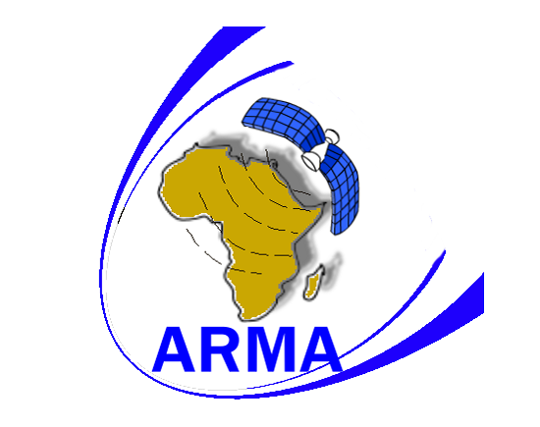

INTERNATIONAL CIVIL AVIATION ORGANIZATION

FIFTEENTH Meeting of the RVSM Task Force
(DAKAR, 11 MAY, 2009)

Agenda Item 4: Follow up of the activities of ARMA
  - Establishment of an ARMA Scrutiny Group

Presented By: ARMA

SUMMARY: This Working Paper discusses and provides insight into the formation of the ARMA Scrutiny Group
to analyze and validate AFI RVSM Large Height Deviations

INTRODUCTION

During the Global Regional Monitoring Agency (RMA) meeting held in Montreal during May 2008, ARMA was requested to establish an AFI RVSM scrutiny group which each RMA is expected to have. This group will essentially Analyze and Validate AFI RVSM Large Height Deviations and where applicable propose remedial actions and procedures which will be taken up through the ARMA processes.

ARMA proceeded and initiated the establishment of the Scrutiny Group by presenting the requirement to the AFI RAN 8 meeting which was recently held during November 2008. AFI RAN 8, in Recommendation 6/8 (e), recommended that AFI States support the establishment of the ARMA Scrutiny Group in 2009.

DISCUSSION

The establishment and outputs of the ARMA Scrutiny Group will be essential to the monitoring activities of the ARMA and will serve to provide validated Large Height Deviation occurrences for assessment in the annual Collision Risk Assessment. The Group should be formalized and have met at least once before the next Collision Risk Assessment in order to provide the required input. In taking counsel from experiences gained by other RMA’s it is envisaged to keep the group small, representative and thus effective in order to obtain the best desired result. It is essential that we consider budgets and distances that need to be travelled in AFI to reach a venue. Further to this in order to reach an equitable arrangement it should be considered to alternate between ARMA, Johannesburg South Africa and ASECNA, Dakar Senegal as far as this is practical. It is therefore the well considered intention of ARMA to propose that the Scrutiny Group be managed and formalized as follows:

Table 1: Venue ARMA Johannesburg South Africa

ARMA x 2 | Facilitator & Secretarial Duties | Located in South Africa No Travelling
IFATCA x 1 | Validated Area Controller | South African Controller Tasked by IFATCA No Travelling
IFALPA x 1 | Regional Pilot | South African Pilot Tasked by IFALPA No Travelling
ASECNA x 1 | Validated Area Controller | Member will need to travel
ICAO ESAF x 1 | ATM Officer | Member will need to travel

Table 2: Venue ASECNA Dakar Senegal

ARMA x 1 | Facilitator & Secretarial Duties | Member will need to travel
IFATCA x 1 | Validated Area Controller | Controller Tasked by IFATCA Travel to be Considered
IFALPA x 1 | Regional Pilot | Senegal Pilot Tasked by IFALPA No Travelling
ASECNA x 1 | Validated Area Controller | No Travelling
ICAO WACAF x 1 | ATM Officer | No Travelling

It is envisaged that the group meets once in a twelve month period and that this date should be strategically placed so that the output can be worked into the Collision Risk assessment for the period under review. The initial meeting will provide a more realistic estimate of the time required to complete the task however the planning for the first meeting will allocate three days to complete the agenda.

Attached as Appendix A is the Draft Terms of reference which will be subject to amendment after the Groups first meeting

ACTION BY THE MEETING

The meeting is requested to:

- Take general note of the establishment of the Scrutiny Group WP for future reference

- Approve the Scrutiny Group composition and meeting venues

- Approve the Draft Terms of Reference

END

