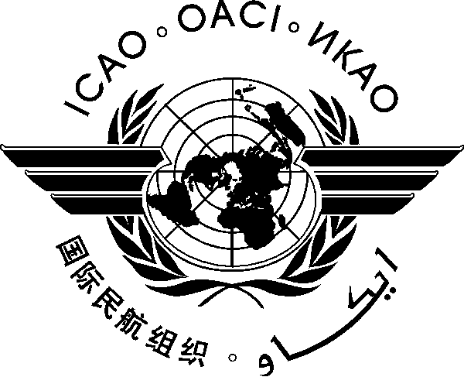
INTERNATIONAL CIVIL AVIATION ORGANIZATION
WESTERN AND CENTRAL AFRICAN OFFICE

ICAO Regional seminar/workshop for National Continuous Monitoring Coordinators (NCMC)
(Dakar, Senegal, 10 – 14 September 2012)

REGISTRATION FORM

Please provide all the requested information and return by E-mail to:
icaowacaf@dakar.icao.int and evoudri@dakar.icao.int

First Name
(in block letters)

Family Name ________________________________________________________________
(in block letters)

State/Organization :

Official designation in
Government/Organization :

address

Téléphone :

Fax :

e-mail :

Signature : Date :

