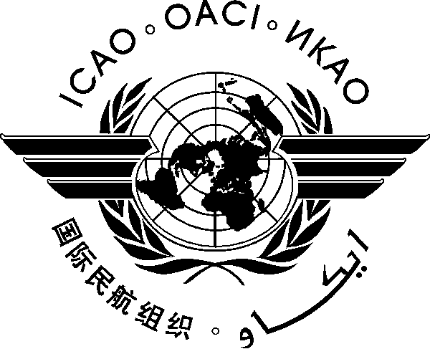
INTERNATIONAL CIVIL AVIATION ORGANIZATION

FIRST AFI REGIONAL AVIATION SAFETY GROUP MEETING
(RASG-AFI/01)
(Kampala, Uganda, 26-27 March 2012)

REGISTRATION FORM

Please return to icaowacaf@dakar.icao.int copy icaoesaf@icao.int or icao@icao.unon.org

Name
(in block letters):

State/Organization :

Official designation in
Government/Organization :

Permanent address to which
mail should be sent after
departure:

Telephone :

Fax :

e-mail :

Local Hotel and
Room Number :

Signature : Date :

