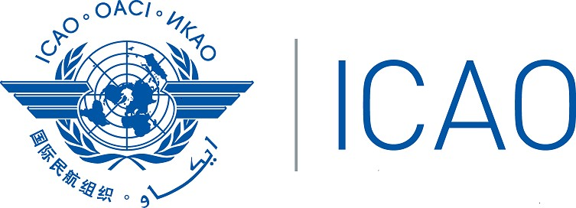
International Civil Aviation Organization
Western and Central Africa Regional Office

Regional Workshop on Aircraft Accident and Incident Investigation (AIG) within AFI States (Cotonou, Benin from 12 to 15 November 2019).

Registration Form

PLEASE COMPLETE CLEARLY AND SEND BACK TO THE ADDRESS BELOW

1. Name and Given name (s):

2. Designation/Title:

3. Organization:

3. Country:

4. Mailing address:

5. Email:

6. Phone:

7. Signature _________________________ Date ________________________

Please send back to adieme@icao.int with copy to aousmane@icao.int

