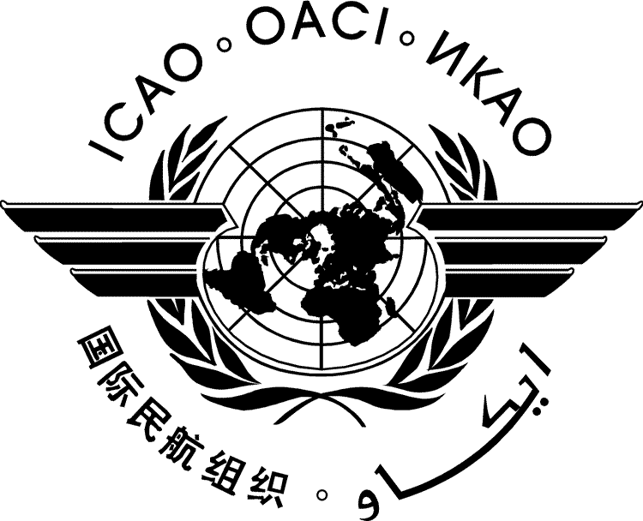 | International Civil Aviation Organization  WORKING PAPER
  A37-WP/yyyy
  EC/yy
  ../../10
  (Information paper)
ASSEMBLY — 37TH SESSION

ECONOMIC COMMISSION

Agenda Item | ##: | Title of agenda item

TITLE

(Presented by ...)

EXECUTIVE SUMMARY
Start text here
Strategic Objectives: | This working paper relates to Strategic Objectives...
Financial implications:
References:

- INTRODUCTION
  - ...

